Assessment Task 2: Project Portfolio

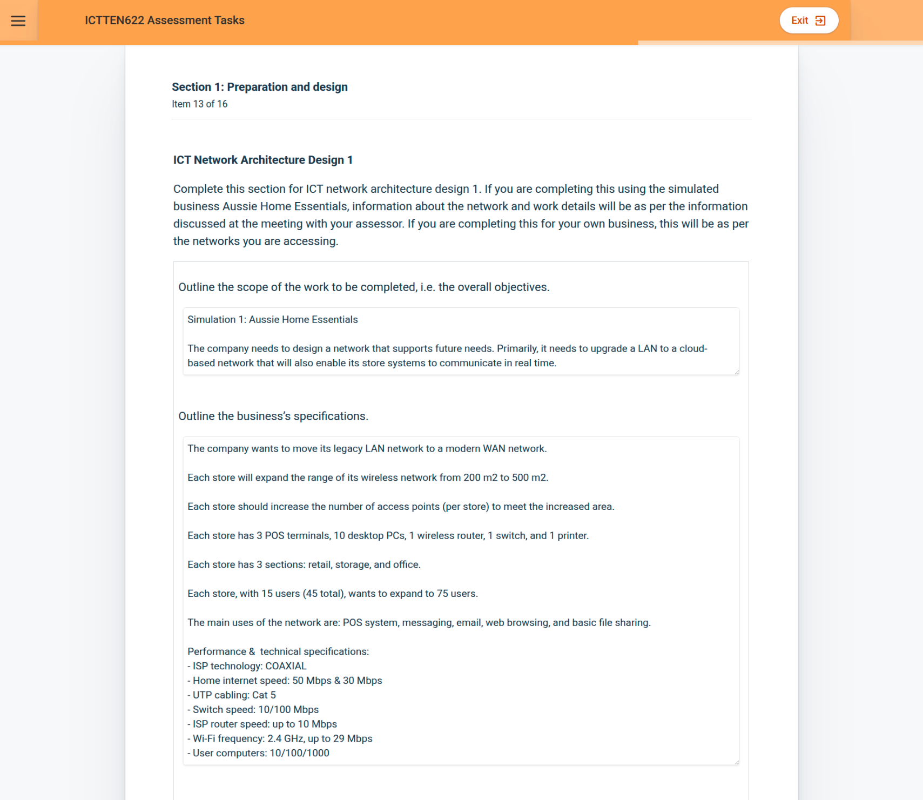

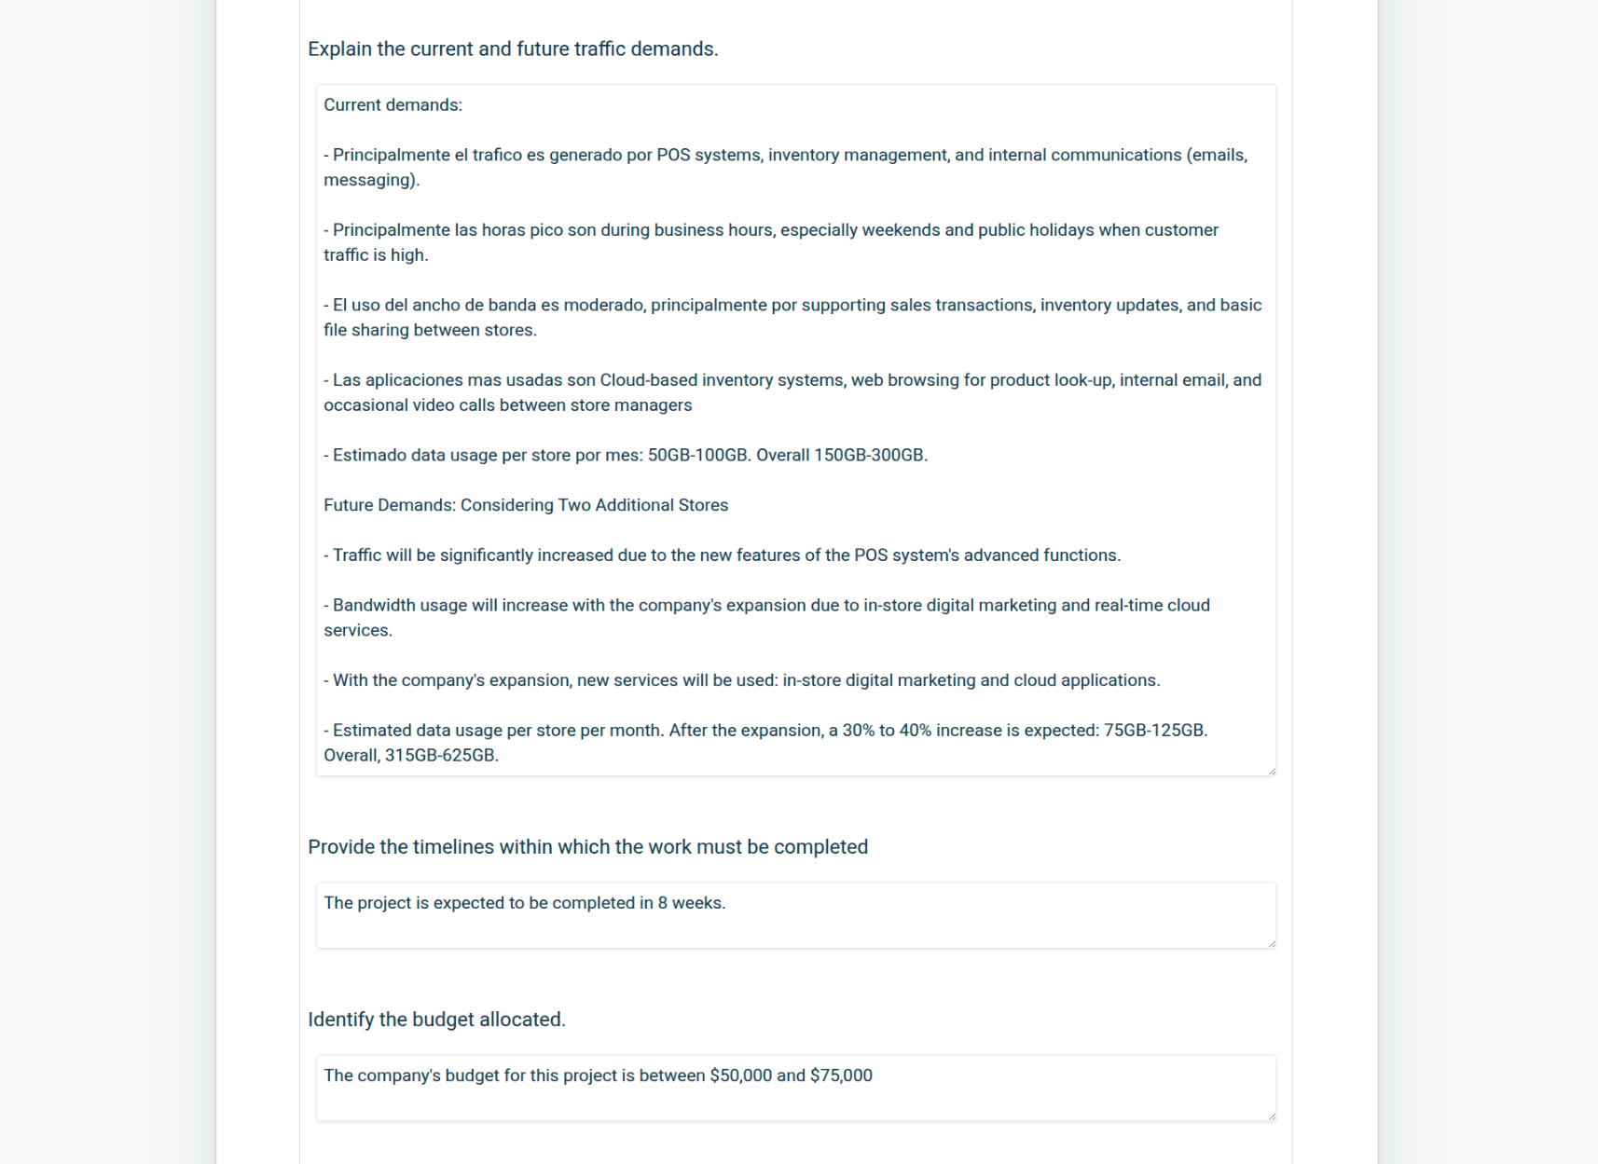

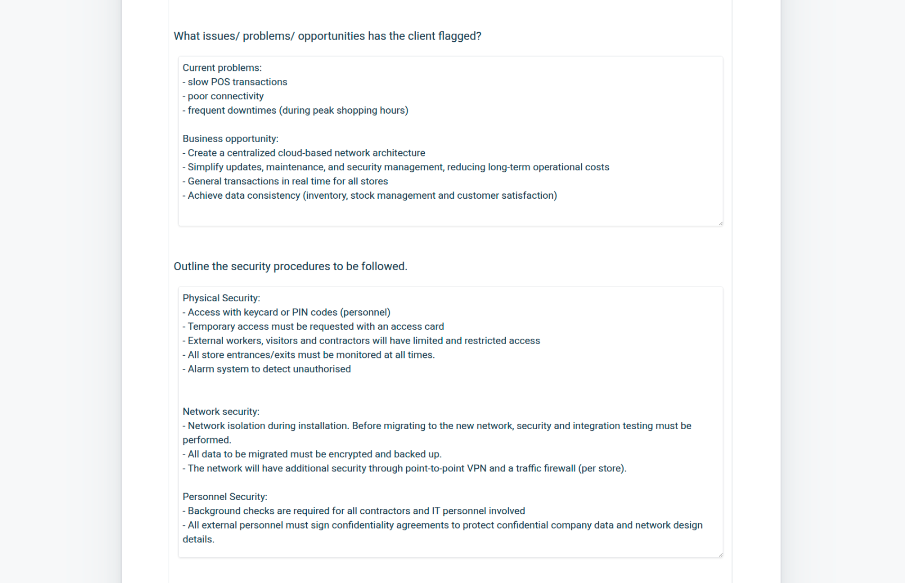

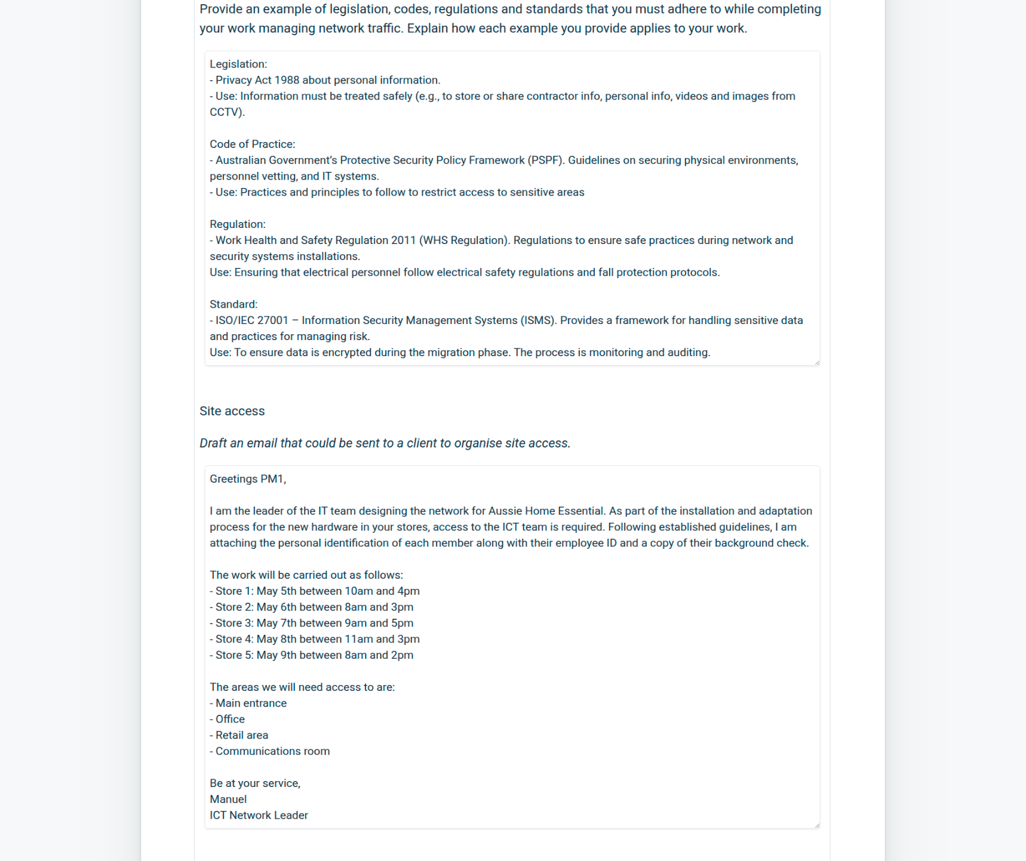

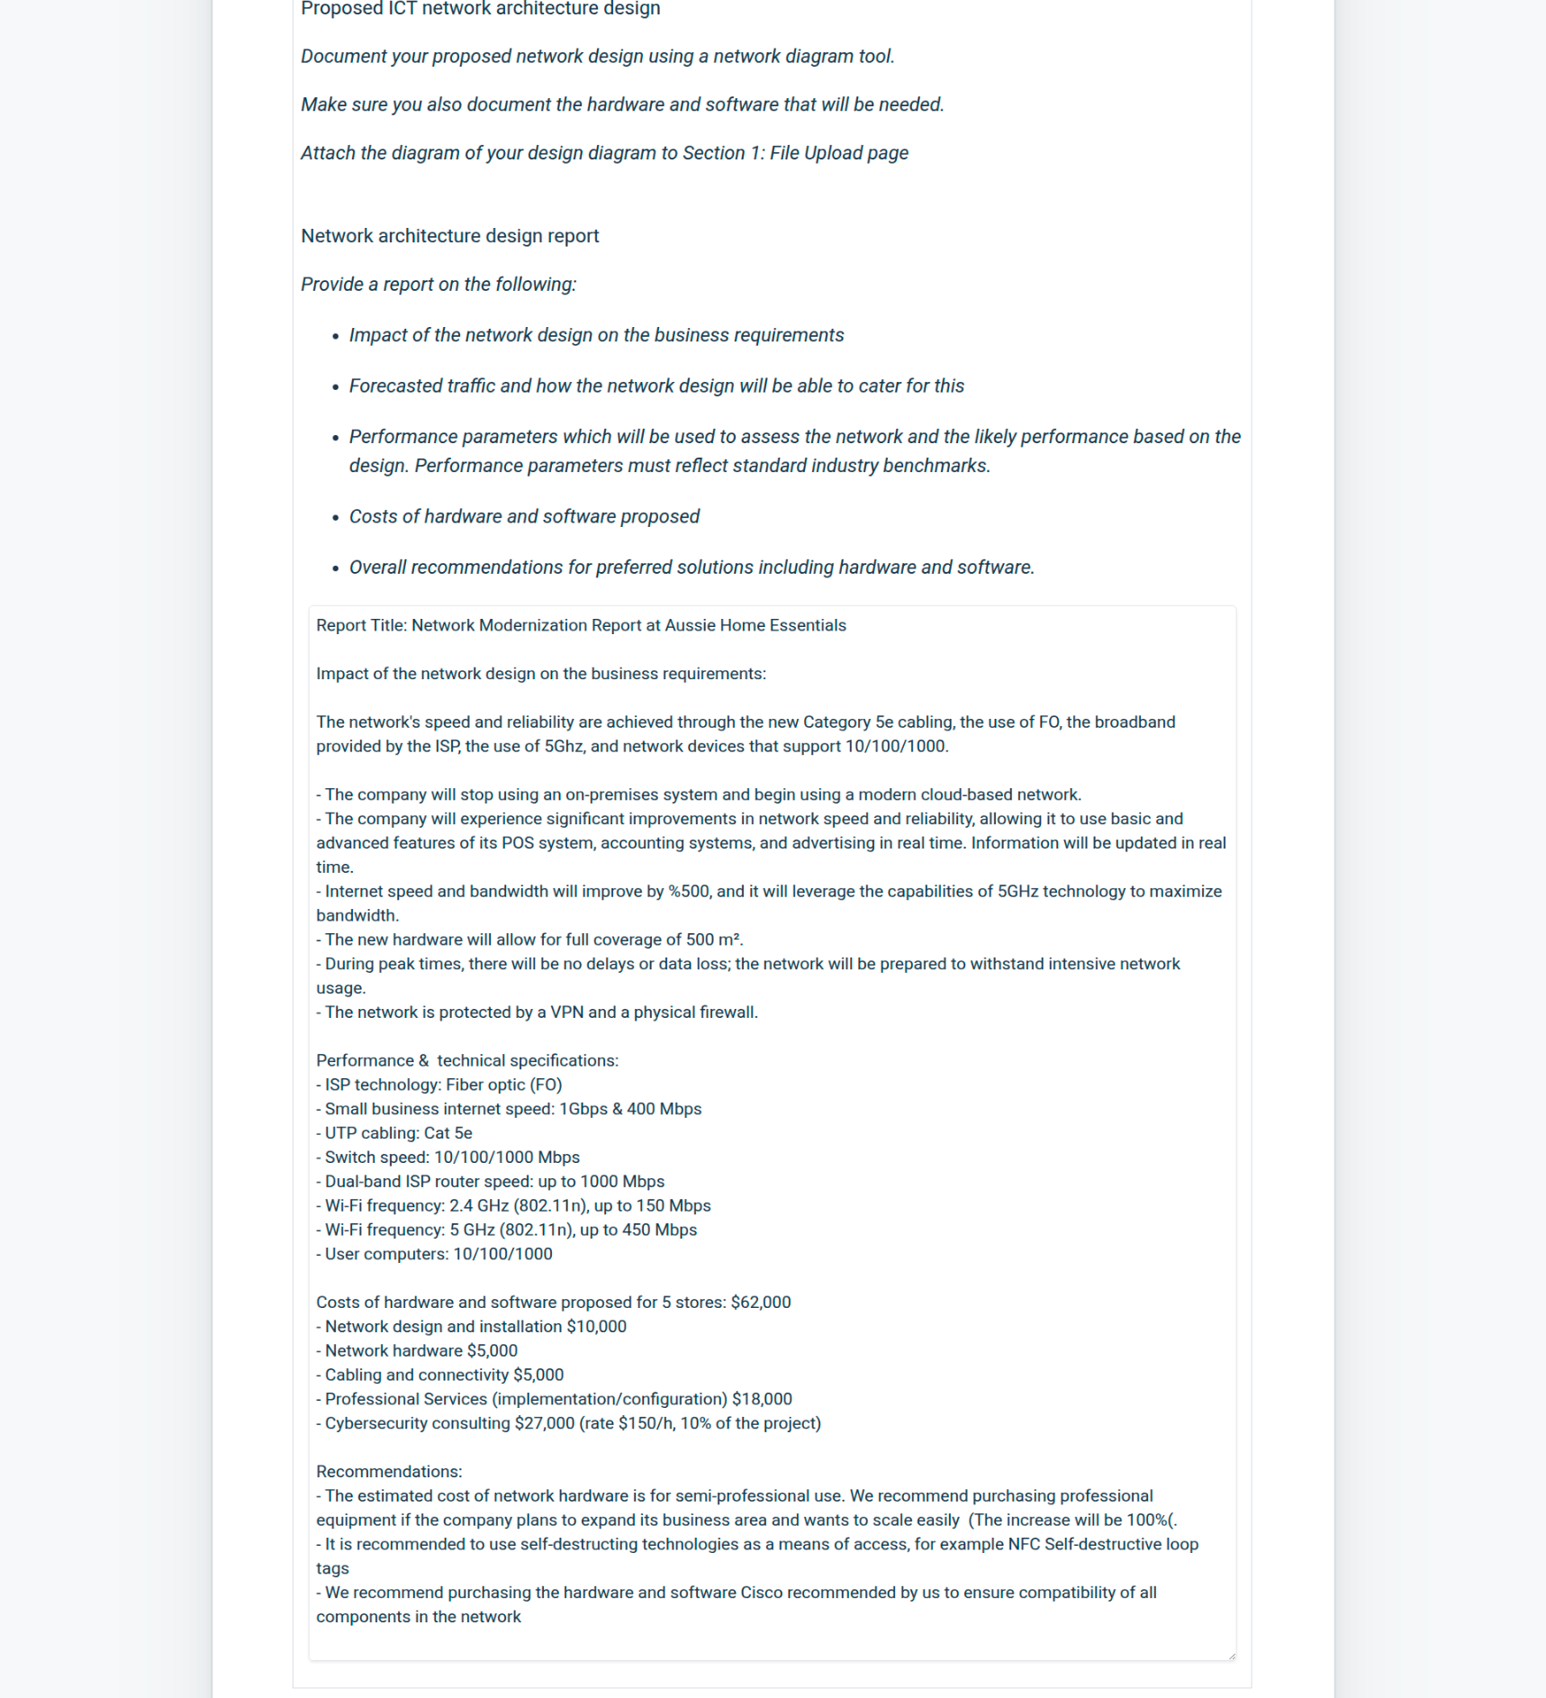

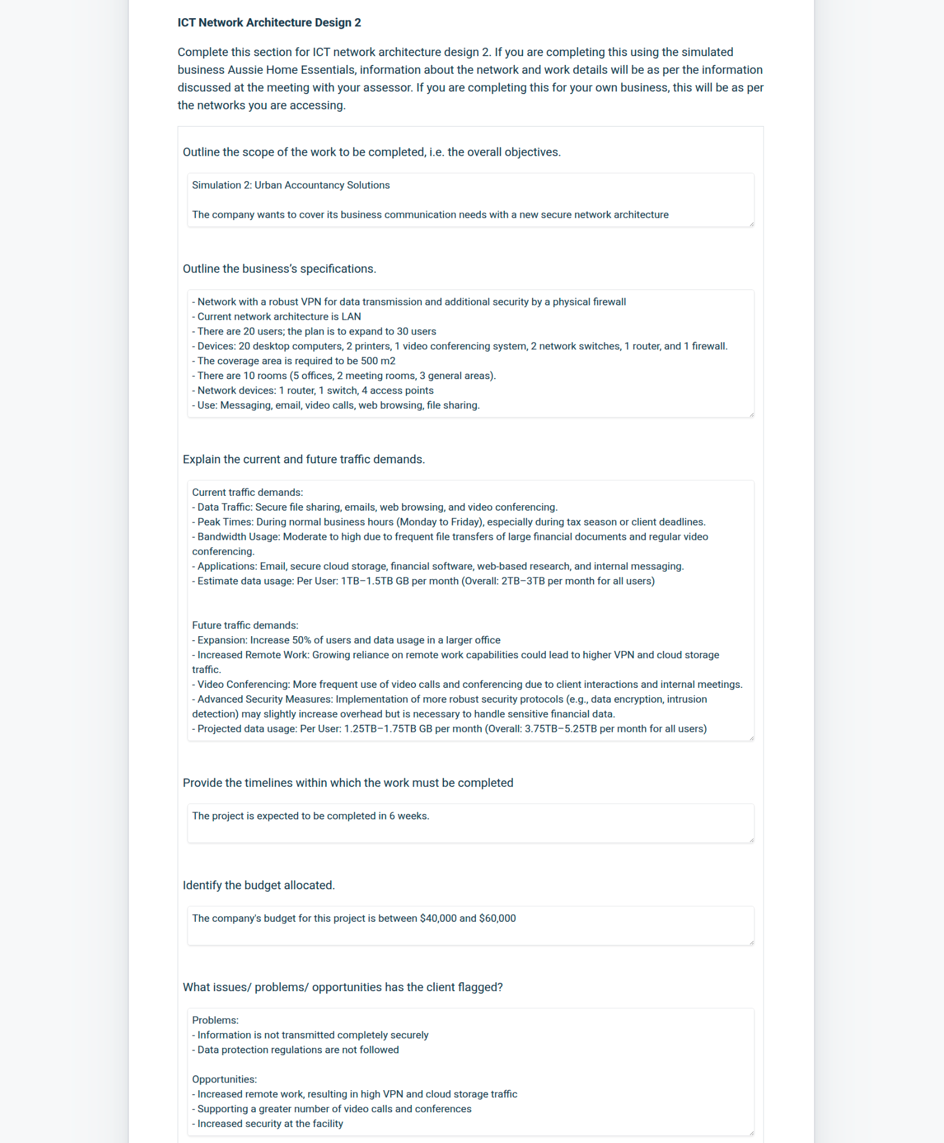

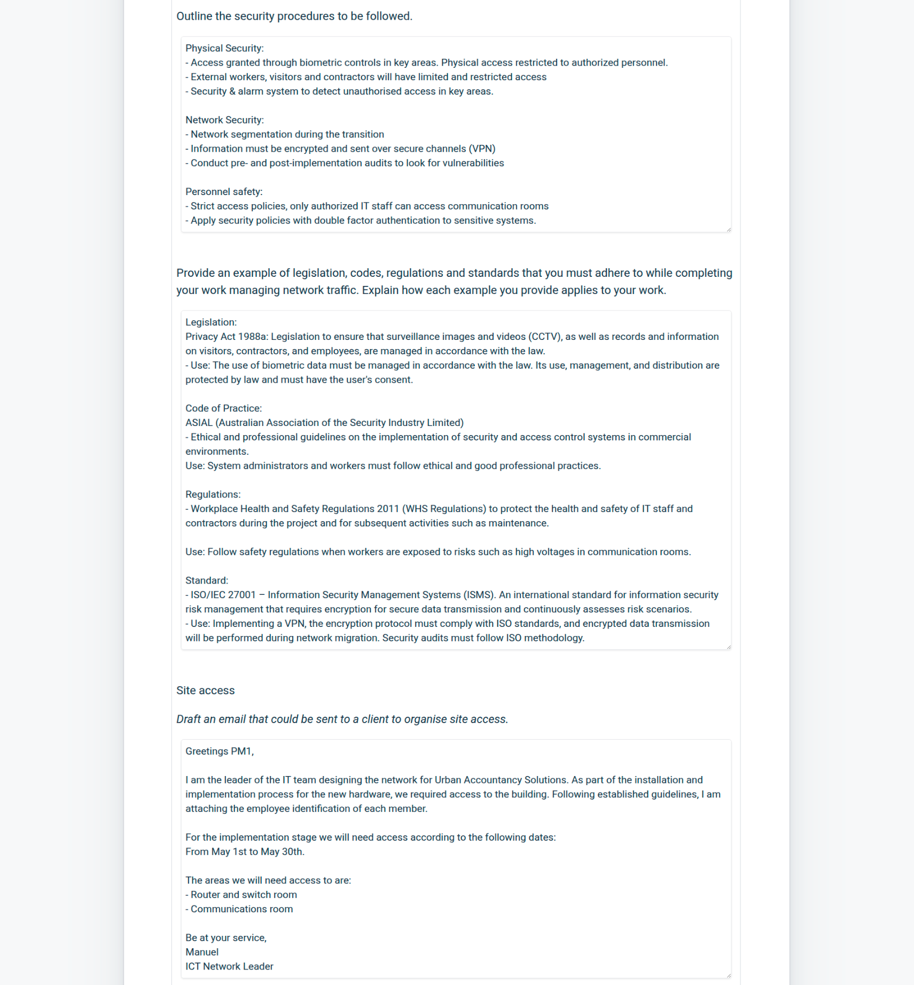

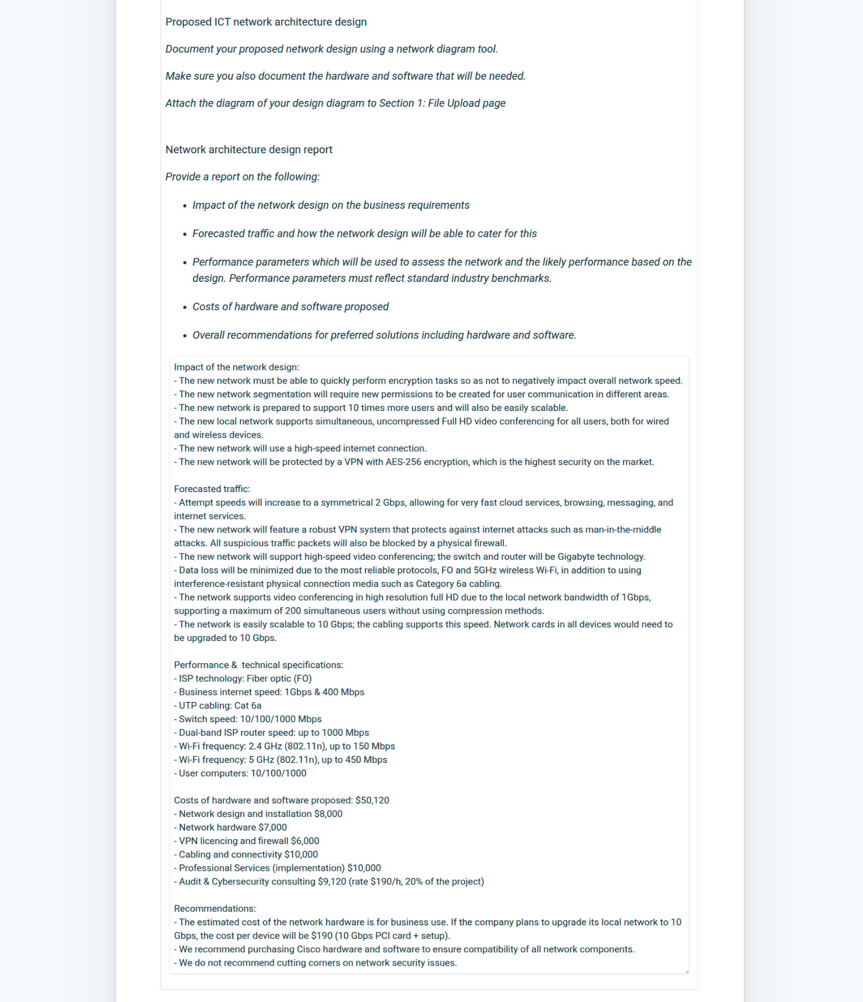

Training and support

Training on the new physical security system. To inform all employees about:

- new physical security regulations

- access to restricted areas

- reporting suspicious events

- reporting emergencies

- visitors

- use of the self-destructing TAG system.

CCTV system training. To introduce the cloud-based surveillance system

- information use consent

- new regulations.

Cybercrime training. To raise employee awareness of online risks.

- New regulations

- Phishing and cyberattacks

- Protection of corporate information

Workplace safety training

- health and safety regulations

- safety standards

- mandatory use of PPE in risk areas

Cloud-based POS system training

- POS system usage

- How to check status/fetch new data

- Issue reporting

New Technology Training

- How to use the 5GHz network, differences, and advantages

- Limitations and advantages of 2.5GHz/5GHz

- How to use new marketing real-time system

*****************

Training and support

Training on the new physical security system with biometric readers. To inform all employees about:

- new physical security regulations

- access to restricted areas

- reporting suspicious events

- reporting emergencies

- visitors

- use of the self-destructing TAG system.

CCTV system training. To introduce the cloud-based surveillance system

- consent to the use of biometric information

- new regulations.

Cybercrime training. To raise employee awareness of online risks.

- New regulations

- Phishing and cyberattacks

- Protection of corporate information

Workplace safety training

- health and safety regulations

- safety standards

New Technology Training

- How to use the 5GHz network, differences, and advantages

- Limitations and advantages of 2.5GHz/5GHz

- FO and uses for multicast video-conferences in FullHD

Security training

- How to verify that you are connected to a VPN

- How to send encrypted information on the internet

- General information on data privacy

******

Best regards, PM1,

The next stage of the implementation of your company's new network requires your approval of the designs we have submitted.

All technical documentation, as well as the designs for the different stores and the work schedule, have been sent to the IT department.

I look forward to your response. If you have any questions about the design, please do not hesitate to contact me.

Sincerely,

Manuel_P

*****

Best regards, PM1,

It's a pleasure to assist you in the implementation of your company's new network. To continue with the process, please indicate your approval of the design we presented.

We understand the importance of security for your company, which is why all technical documentation, general recommendations, the design, and the work schedule have been sent to the IT department.

I look forward to your response. If you have any questions about the design, please do not hesitate to contact me.

Sincerely,

Manuel_P